UNIT 5: MARKOV PROCESSES

Part-B

**Question 1:**

_________________________________________________________________

If the transition probability matrix of a Markov chain is . Find the steady-state distribution of the chain.

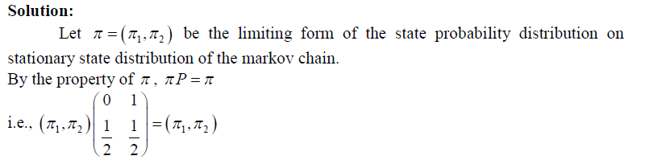

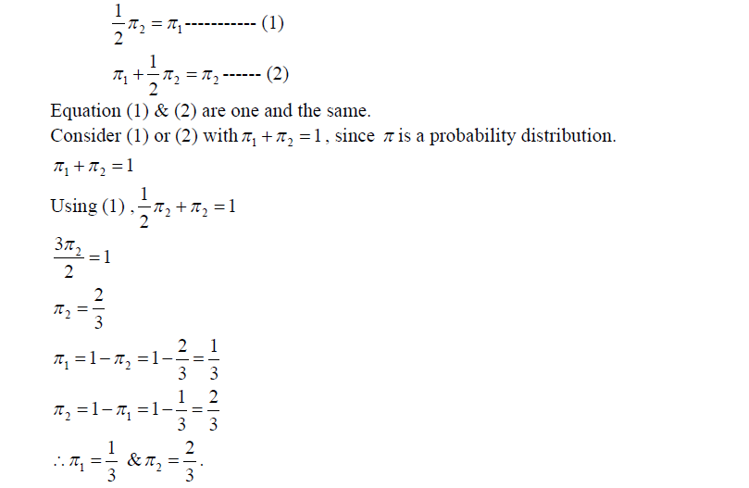

**Question 2:**

Explain how you would clarify the states and identify different classes of a Markov chain.

________________________________________________________________

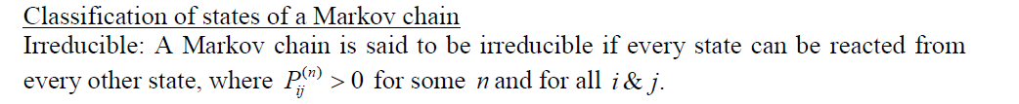

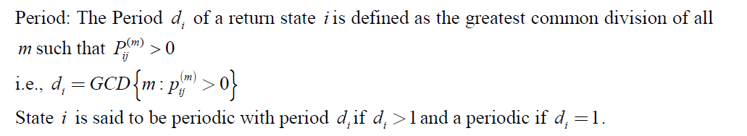



**Question 3:**

___________________________________________________________________



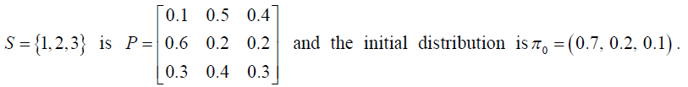





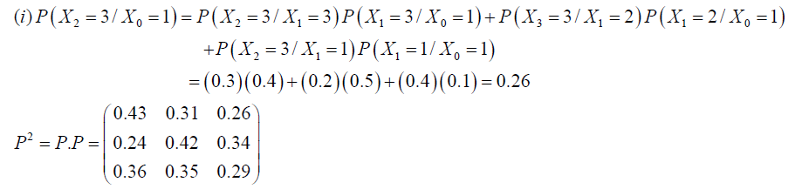

**Question 4:**

___________________________________________________________________





.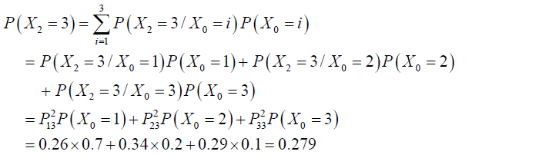

**Question 5:**

**___________________________________________________________________**







Solution:

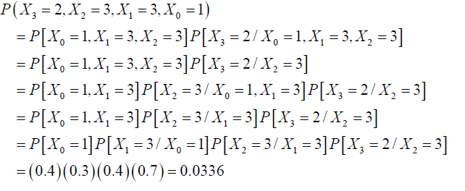

**Question 6:**

Let the TPM of a given matrix be P =. Is the chain ergodic?

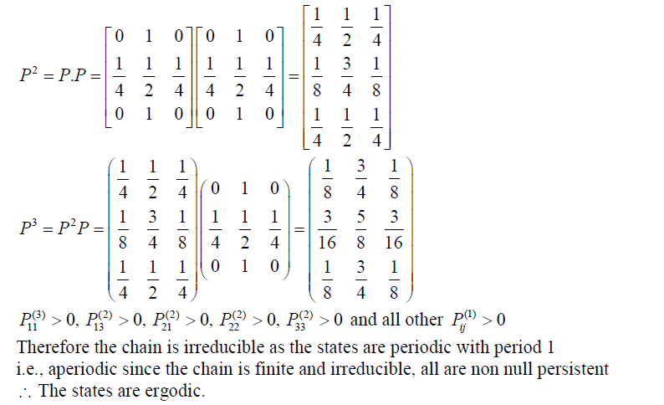

**Question 7:**

**_____________________________________________________________**





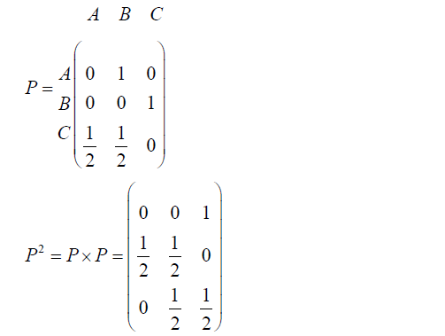

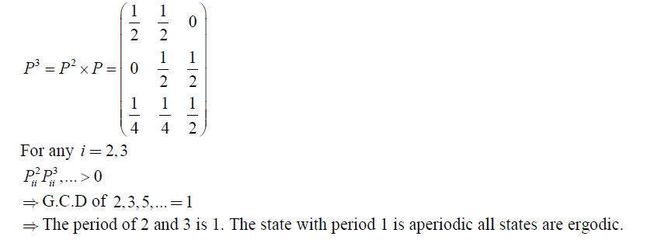

**Question 8:**

**______________________________________________________________**



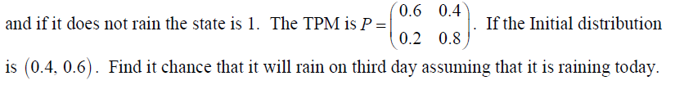

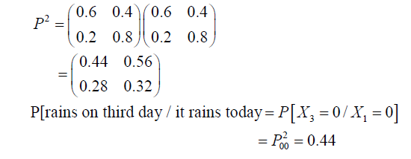

**Question 9:**

**_**_________________________________________________________________

The tpm of a markovchain is given by .

Find the steady state probability distribution.



_____ (1)

=_________(2)

_________(3)

Solving (1), (2),(3) we get , 

**Question 10:**

__________________________________________________________________

The tpm of a markov chain is given by.

Find the probability distribution in the long run.

**Solution:**



­­­­­­­­­





solving (1) ,(2)and (3) , we get the result.

**Question 11:**

___________________________________________________________________________

Let p=  represent the tpm of a markovchain.The values of x1 and x2 are

(i)  (ii)  (iii)  (iv) 

Since Sum of each row is 1.

Therefore  gives x= 0.7

Similarly 0.5+ x= 1 gives x2 = 0.5

**Question 12:**

_________________________________________________________________

Three boys A, B and C are throwing a ball to each other. A always throws to B and B always throws to C, but C is as likely to throw the ball to B as to A. Find the thetransition probability matrix.

Solution:

The transition probability matrix is

P = 

**Question 13:**

__________________________________________________________________The period of each state in the tpm****is

(i) 1 (ii) 2 (iii) 3 (iv) 4

Hint:  and 

GCD {2,3,….} = 1.

**Question 14:**

_________________________________________________________________

Let  be a Markov chain with state space  and 1 – step Transition probability matrix 

Check it is (i) Finite, irreducible and non null persistent (ii) Finite, reducible and non null persistent (iii) Finite , irreducible and transient.Finite, irreducible and transient (iv) Finite, irreducible and null persistent

Solution:



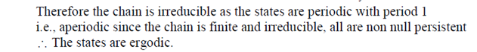

**Question 15:**

__________________________________________________________________

Consider the Markov chain with transition matrix

. Show that it is irreducible and aperiodic.

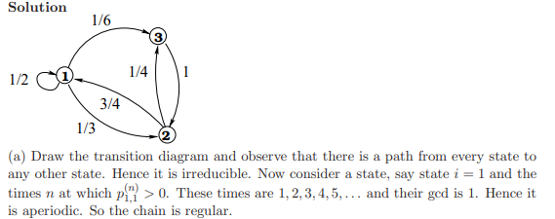

**Question 16:**

__________________________________________________________________

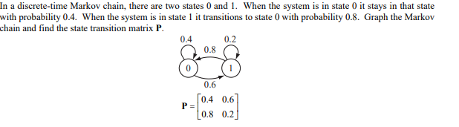

**Question 17:**

_________________________________________________________________

.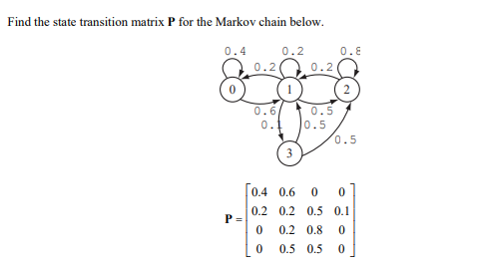

**Question 18:**

**____________________________________________________________________________**

A man either drives a car or catches a train to go to office each day. He never goes 2 days in a row by train but he drives one day, then the next day he is just as likely to drive again as he is to travel by train. Now suppose that one the first day of the week, the man tossed a fair dice and drove to work iff a 6 appeared. Find the probability that he takes a train on the third day

Solution:

State Space = (train, car)

The TPM of the chain is



P (traveling by car) = P (getting 6 in the toss of the die)=

& P (traveling by train) =







P (the man travels by train on the third day) =

**Question : 19**

__________________________________________________________________

Define a Markov process with an example.

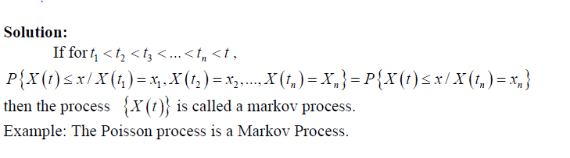**Question 20:**

__________________________________________________________________

Define a Markov chain with an example.

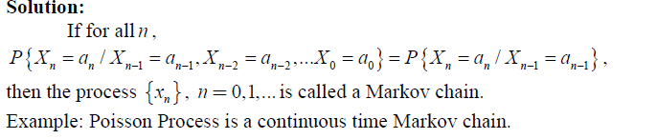

**Question 21:**

_________________________________________________________________

What is a stochastic matrix? When is it said to be regular?

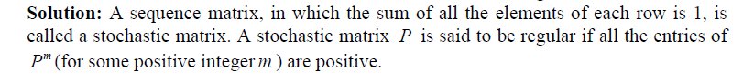

**Question 22:**

___________________________________________________________________

A man either drives a car or catches a train to go to office each day. He never goes 2 days in a row by train but he drives one day, then the next day he is just as likely to drive again as he is to travel by train. Find the probability that he drives to work in the long run.

Solution:

State Space = (train, car)

The TPM of the chain is



Let be the limiting form of the state probability distribution or stationary state distribution of the Markov chain.

By the property of, 







&

Solving 

P{The man travels by car in the long run }=.

**Question 23:**

______________________________________________________________________________**Find the nature of the states of the Markov chain with the TPM  and the state space.**

Solution:









Also 





The Markov chain is irreducible.

Also  for all .

The states of the chain have period 2. Since the chain is finite irreducible, all states are non null persistent. All states are not ergodic.